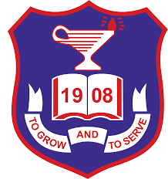

22nd *of November 2018*

This is to confirm that **Team Singularity Racing** has been officially selected to participate in the **National Cyprus finals** in March 2019 for the F1 in schools Challenge.

F1 in schools is the only global multi-disciplinary challenge in which teams of students of school age deploy CAD/CAM software to collaborate, design, analyse, manufacture, test and then race a miniature compressed air powered F1 car.

We feel that the challenge inspires students to use IT, Physics, Mathematics and Design & Technology to learn about the underlying principles of Physics, aerodynamics, design, manufacture, branding, graphics, sponsorship, marketing, leadership/teamwork, media skills and financial strategy and apply them in a practical, imaginative, competitive and exciting way.

We would like to wish **Team Singularity Racing** every success in the National Cyprus finals 2018-19.

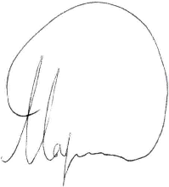Mr Stelios Theodosiou Dr Andreas Lampis

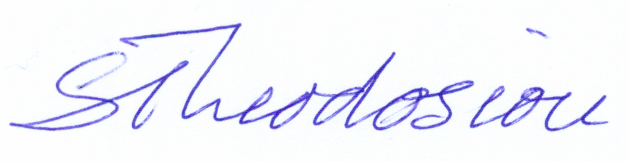

I/C F1 in schools .Cy Teacher of Physics

HoD Design & Technology

The English School, Nicosia The American Academy, Larnaca

[theodosiou.stelios@englishschool.ac.cy](mailto:theodosiou.stelios@englishschool.ac.cy) alampis@academy.ac.cy